Your answers must be recorded on this exam. This is a closed book, closed notes, (and closed neighbor) exam. You may ask the instructor questions but do not disturb your classmates. The Radford University Honor Code will be strictly enforced!

Questions 1-6 are short answer, fill in the blank, true/false and multiple choice. Each questions is worth 5 points.

- List in order the five steps in the Waterfall model of software development.

- An iterator that throws an exception when the underlying collection is modified while the iterator is in use is said to be _________________.

- A ____________ is a Java concept that allows the developer to design how a class can be used without specifying the implementation where as a _____________ will implement some but not all of the methods.

- Saying that, for example, a student is a person is an example of where we would use a _____________ relationship where as saying that a deck class can be built with a bag is an example of a _______________ relationship.

Questions 5 and 6 relate to the following UML diagram.
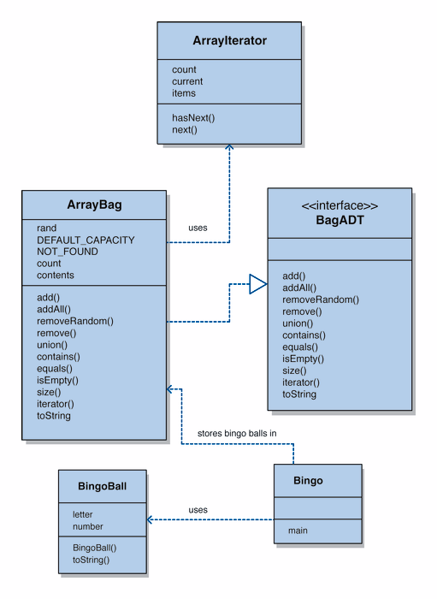

- In the ArrayBag class, add() is a _______________ while count is a _______________.

- The relationship between ArrayBag and BagADT is an example of ____________.
  - Implementation
  - Aggregation
  - Inheritance
  - None of the above

Question 7 is worth 20 points.

- The add operation for our array implementation of a bag assumed that since order does not matter in a bag we would always add to the rear of the list. Modify the add operation to create an addAfter method. The addAfter method will have the following heading:

public void addAfter(Object element, Object target)

The addAfter method will find (use the equals method of the object to determine equality) the designated target in the array (throw an exception if it does not exist), then shift all of the elements in the array from the next position up and insert the element into the position after the target. For example, if the array contained the following:

7 3 4 8 1 9 2

the result of addAfter( new Integer(5), new Integer(4)) should be

7 3 4 5 8 1 9 2

//------------------------------------------------------
// Adds the specified element to the bag, expanding the capacity
// of the bag array if necessary.
//------------------------------------------------------
public void add (Object element)
{
if (size() == contents.length)
expandCapacity();

contents[count] = element;
count++;
}

